Secure Public-Facing Application Platform
Supplemental Assignment – Enterprise Security (Cloud and IoT)
Student: Rethabile Ramotadima
Student ID: X00185517
GitHub Link - https://github.com/Thabile11/Supplemental-CA

System Overview
The goal of this project is to develop an Ubuntu Server LTS virtual machine hosted in VirtualBox as the server environment, with the application deployed using Docker and Docker Compose. The proposed program is made up of three main services, a Nginx reverse proxy, a public Flask web application and a protected Flask administration service.
Nginx is meant to serve as a single public entry point, with application services remaining internal to the Docker environment. This approach reduces unwanted exposure by preventing backend services from being immediately published to the host.
The public application is intended to be accessible via the reverse proxy. A separate administrative service is an example of a secure supporting service that needs authentication. The Docker networks are used to separate the reverse proxy and application services.
The project also includes environment variable configuration, a.env.example file, Docker logging, and test procedures. These are designed to show basic secure configuration, access control, observability and operational verification.
However, the implementation is still incomplete. Development continued through the initial server and application configuration phases when the Docker Compose configuration failed validation due to a YAML formatting mistake. As a result, the ultimate working behaviour of the entire stack could not be displayed.
Architecture Diagram
The planned Architecture Diagram
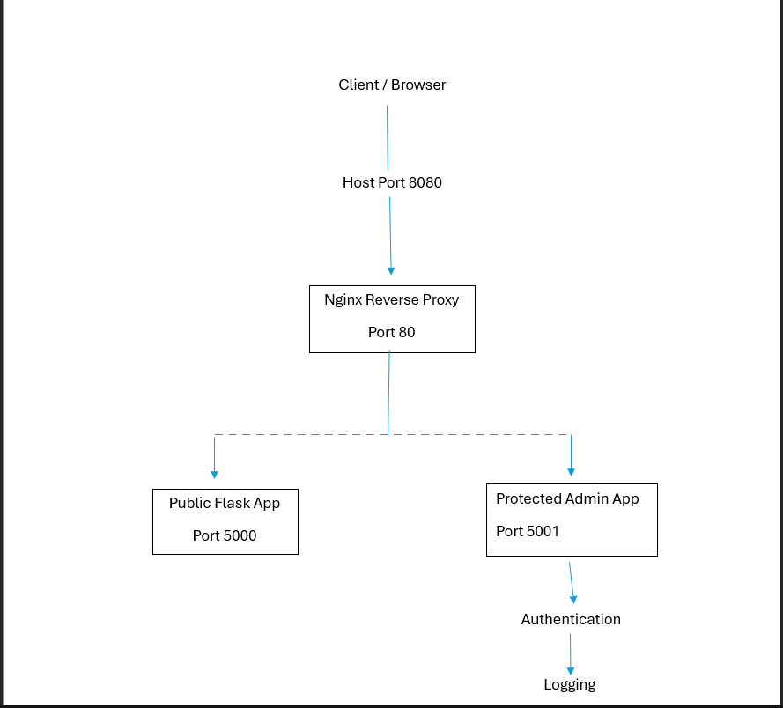
The planned setup separates the services using Docker networks. The reverse proxy is the only component that is designed to have a published host port. Flask services use internal Docker networking and are not meant to be directly accessible to external clients. The public application would be accessible via the Nginx reverse proxy, but the administrator application would require authentication.
Configuration and Secrets Management
The yml file defines the Nginx proxy, public Flask application, and protected administration service and their respective networks, environment variables, volumes, and dependencies.
The reverse proxy is set up to publish port 8080 on the host and route requests to the relevant backend service. Flask services use internal Docker ports instead of releasing them directly. This is meant to implement regulated entrance and minimise unwanted exposure.
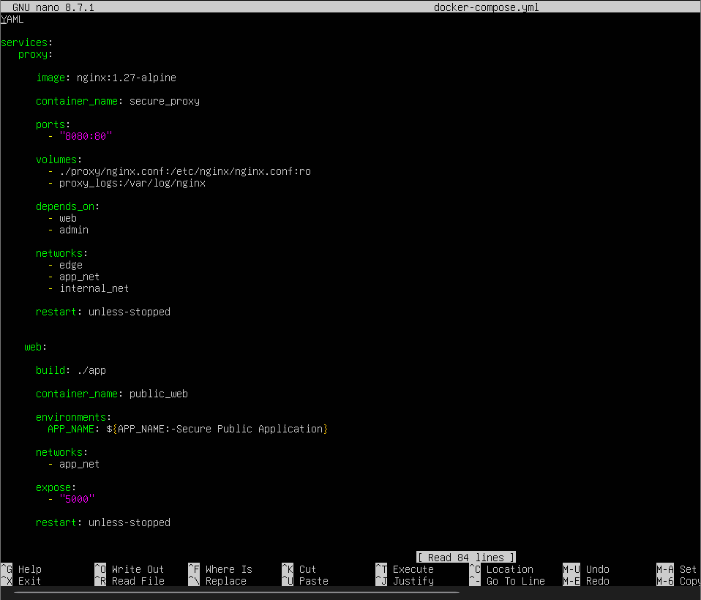
The project also uses different Docker networks. The reverse proxy is meant to communicate with application services through their own networks while preventing backend services from being exposed directly to the host.
Configuration values are provided by environment variables. Created a .env.example file to demonstrate the variables required by the application while excluding actual sensitive information. The original.env file is excluded using nano .gitignore.
It contains:
APP_NAME=Secure Public Application
ADMIN_USERNAME=admin
ADMIN_PASSWORD=(Actual Password)
The purpose of this configuration is to demonstrate that sensitive information should not be inserted into source code or publicly available configuration files.
Implementation and Testing Evidence
Using VirtualBox, I set up an Ubuntu Server LTS virtual system. The server was updated, and Docker was installed. Docker Compose was also installed and confirmed. The project directory structure was established, with folders for the public application, administration service, reverse proxy, configuration, evidence, and screencast material.
Used Docker files to generate the Flask and protected administration applications. A Nginx configuration was also created to support the intended reverse proxy routing. The .env.example and .gitignore files were built to facilitate secure configuration and secret management. But, as the project reached the Docker Compose configuration failed to validate successfully.
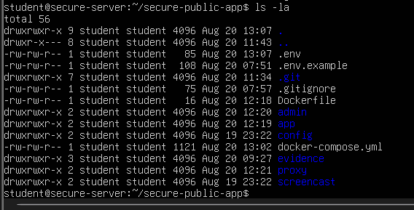
The following command was used:
docker compose config
The command returned a YAML parsing error:
yaml: line 3: mapping values are not allowed in this context
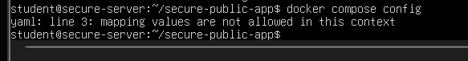
If the YAML setup validates well, the planned tests are:
1. Test the public application by accessing port 8080 and confirming the return of the public page.
2. Perform a reverse proxy test by accessing the health endpoint through Nginx and verifying the right backend response.
3. To test unauthenticated access, navigate to /admin/ without credentials and anticipate an HTTP 401 Unauthorised response.
4. To test authenticated access, provide valid credentials and expect an HTTP 200 OK response.
5. Conduct a network exposure test by inspecting Docker Compose and host listening ports to ensure only the reverse proxy is exposed outside.
6. Logging test: Check container logs for expected behaviour following login attempts, both successful and refused.
These tests would verify the application's availability, routing, access control, network separation, and observability.
Short Security Reflection
The suggested design includes a few security features. Using Nginx as a reverse proxy results in a single controlled entry point rather than directly exposing each application container. Docker networking further separates the public-facing proxy and backend services.
The protected administrative service is designed to show the core Zero Trust principle. A request should not be trusted only because the user can access the service. Access is allowed only after successful authentication. The design therefore highlights the idea of confirming access rather than depending only on network location.
The project also uses environment variables, such as.env.example and.gitignore, to decrease the danger of credential exposure.
Logging was implemented so that application and authentication behaviour could be investigated. In a finished solution, these logs would show that requests were correctly routed and that unauthorised queries were refused.
The main drawback of the current approach is that the Docker Compose configuration was not successfully verified. The problem was triggered by a YAML configuration error.
Overall, the project created the foundation for a secure public-facing application platform, including the Ubuntu server, Docker environment, application components, reverse proxy, networking design, and secrets management strategy. Even though the execution process stopped during Docker Compose validation and is partially completed initial version instead of a fully functioning secure deployment.

